Query Screen shots

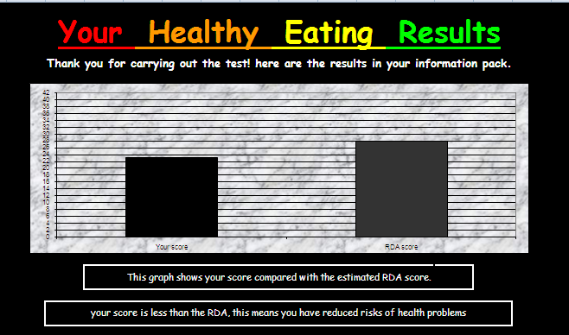

This is my test buddies results. From this graph i can tell that they are eating a good diet which does not have too much fat and salt.

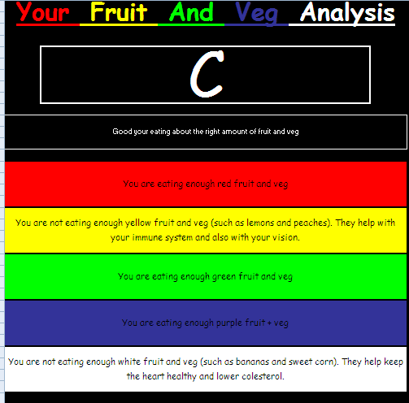
This is the rest of my test buddies results. It shows that they are not eating enough white or yellow fruit and veg. I will be basing my search on white and yellow fruit and veg.

