Query Screen shots

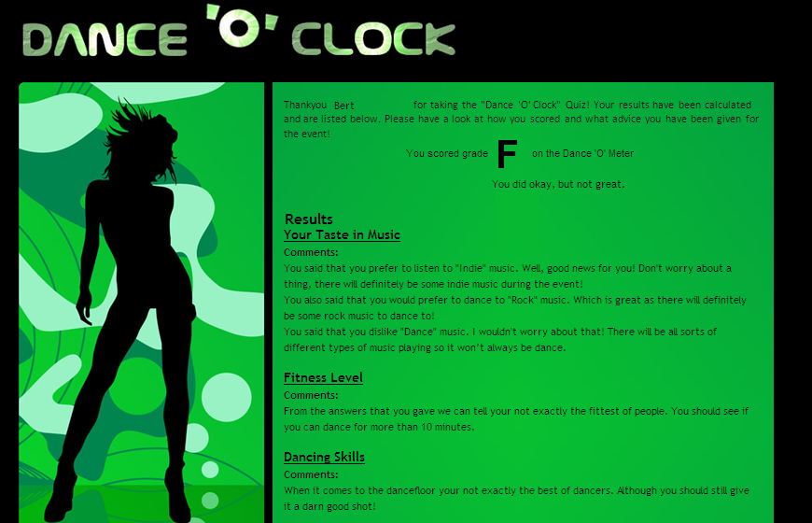
This is the results of my test buddies quiz. They are not too fit so they will need to dance to slower music. They also seem to prefer rock / alternative music rather than dance. I will search for slow rock music in the database.

