Database Screen shots

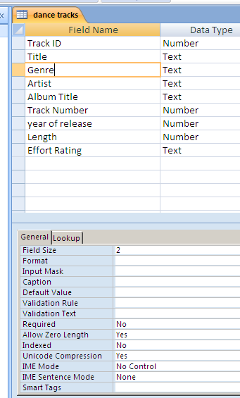
The screen shot to the left shows the fields I added to my table. I put the field s in the same order as the data file in order to make my import run smoothly.
Below are the size and data type of the fields I added :-
Field Name | Data type | Field Size
Track ID | Number
Title | Text | 40
Genre | Text | 2
Artist | Text | 40
Album Title | Text | 40
Track Number | Number
Year of release | Number
Length | Number
Effort Rating | Text | 1

