Database Screen shots

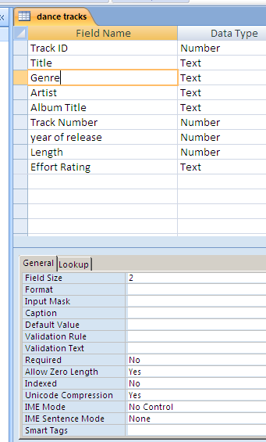
The screen shot to the left shows the fields I added to my table. I put the field s in the same order as the data file in order to make my import run smoothly.
Below are the size and data type of the fields I added :-
Field Name | Data type | Field Size
Track ID | Number
Title | Text | 40
Genre | Text | 2
Artist | Text | 40
Album Title | Text | 40
Track Number | Number
Year of release | Number
Length | Number
Effort Rating | Text | 1

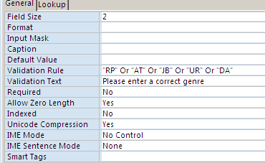
Validation rules
This is the validation rule for genre. Each genre is listed and separated by or. This means that the genre can be dance, or alternative or jazz....

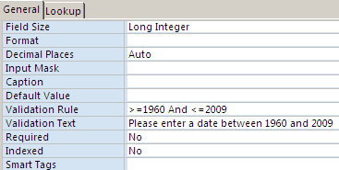
This validation rules makes sure that dates must be between 1960 and 2009

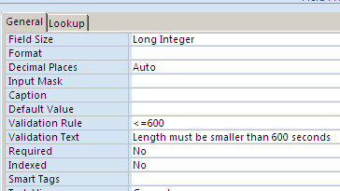
This validation rules makes sure that track lengths are lower than 600 seconds (10 mins)

