Query Screen shots

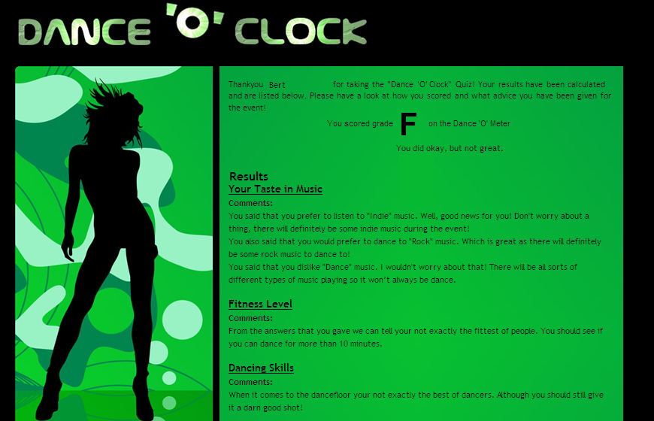
This is the results of my test buddies quiz. They are not too fit so they will need to dance to slower music. They also seem to prefer rock / alternative music rather than dance. I will search for slow rock music in the database.

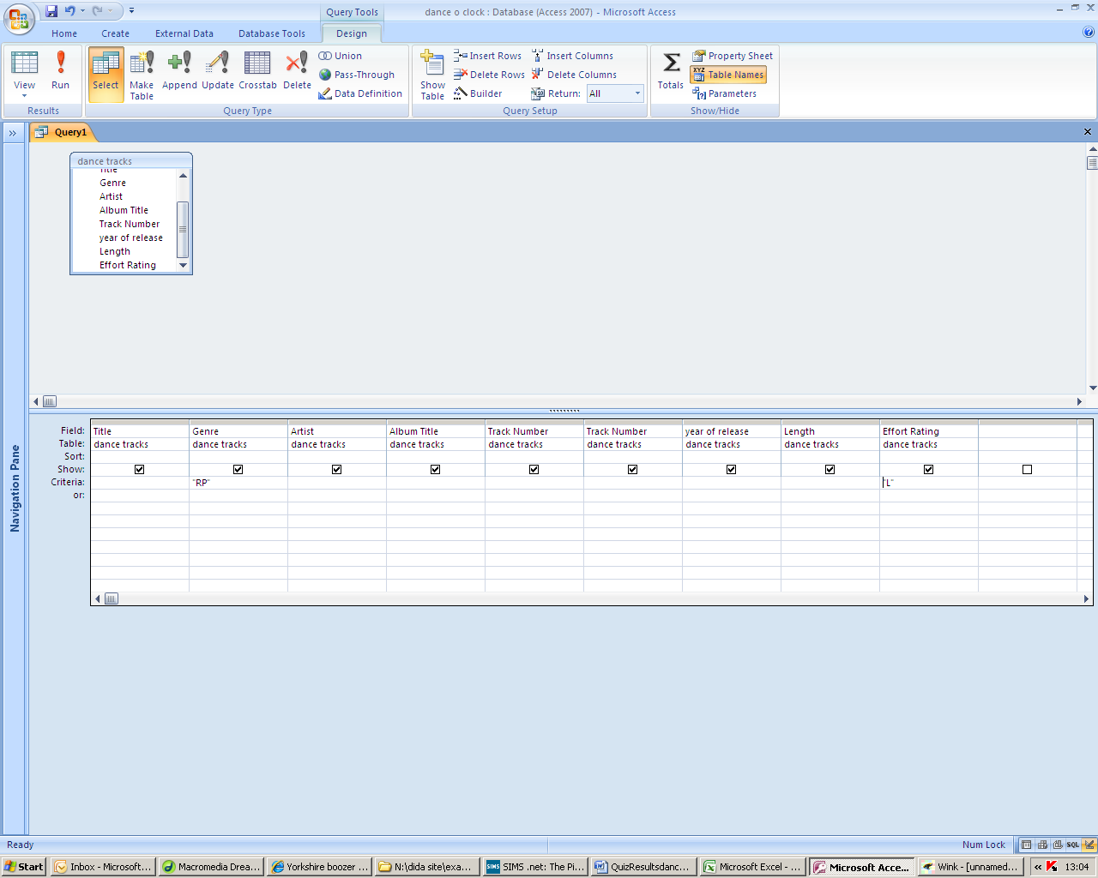

The first query I made looked for “RP” and “L”. Rock and pop and low effort rating.

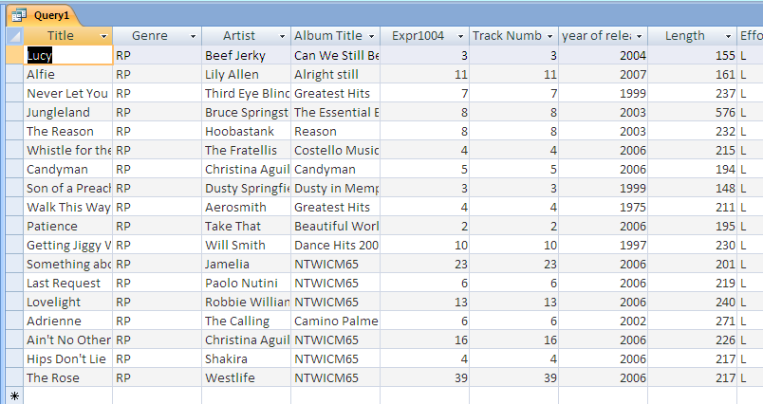
The query produced the following results (18 tracks). This is too many so I need to reduce the amount of tracks returned so the total length is no bigger than 900 seconds. This is specified in the project brief.

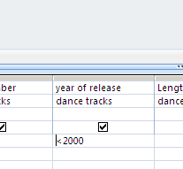
I then tried looking for older music tracks as these are more well known. I did a search for tracks older than the year 2000.

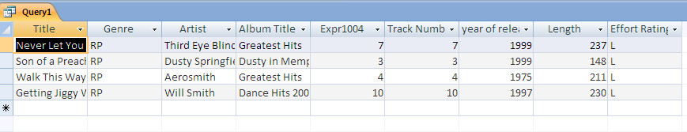
The results i got were much better and I decided that these tracks would be what I will use for the playlist.

