Invitation review
The purpose of the invitation was to encourage teenagers to take part in the dance o clock charity event. This means that the invitation should grab their attention, look cool as well as still being slick and professional. My first attempt was very bland. The feedback said
“I like the images you have used and the colours. However there is too much text and is a bit boring. It would not encourage me to attend a dance event. “

To make it more interesting I reduced the amount of text and made it more persuasive. For example I said “Think your the best? Prove it!” instead of “Take part in the dance o clock”. Setting a challenge to people will encourage them to take part more than just asking them out right.

I feel that my use of images is a strength. The image of a young person dancing makes the event look cool which will encourage people to take part. The image takes up most of the invite and will hopefully make people look at it.

I am not so happy with the text and i think this could be improved. I think a more grungy font like the one below –

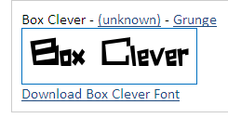
This would tie in with dancing a lot better than the standard windows fonts. I did not use it as it was not installed at school. The font i used was “Veranda” which is easy to read but does not fit in with the theme of dancing. It is better suited for this review!

